 

**Placement Empowerment Program**

***Cloud Computing and DevOps Centre***

60 Days of DevOps Challenge

***Day 6: Advance Python for DevOps***

***Name: Mary Edlyn A Department: CSE***



**Challenge 1: Create a Python script that connects to a remote server via SSH using paramiko.**

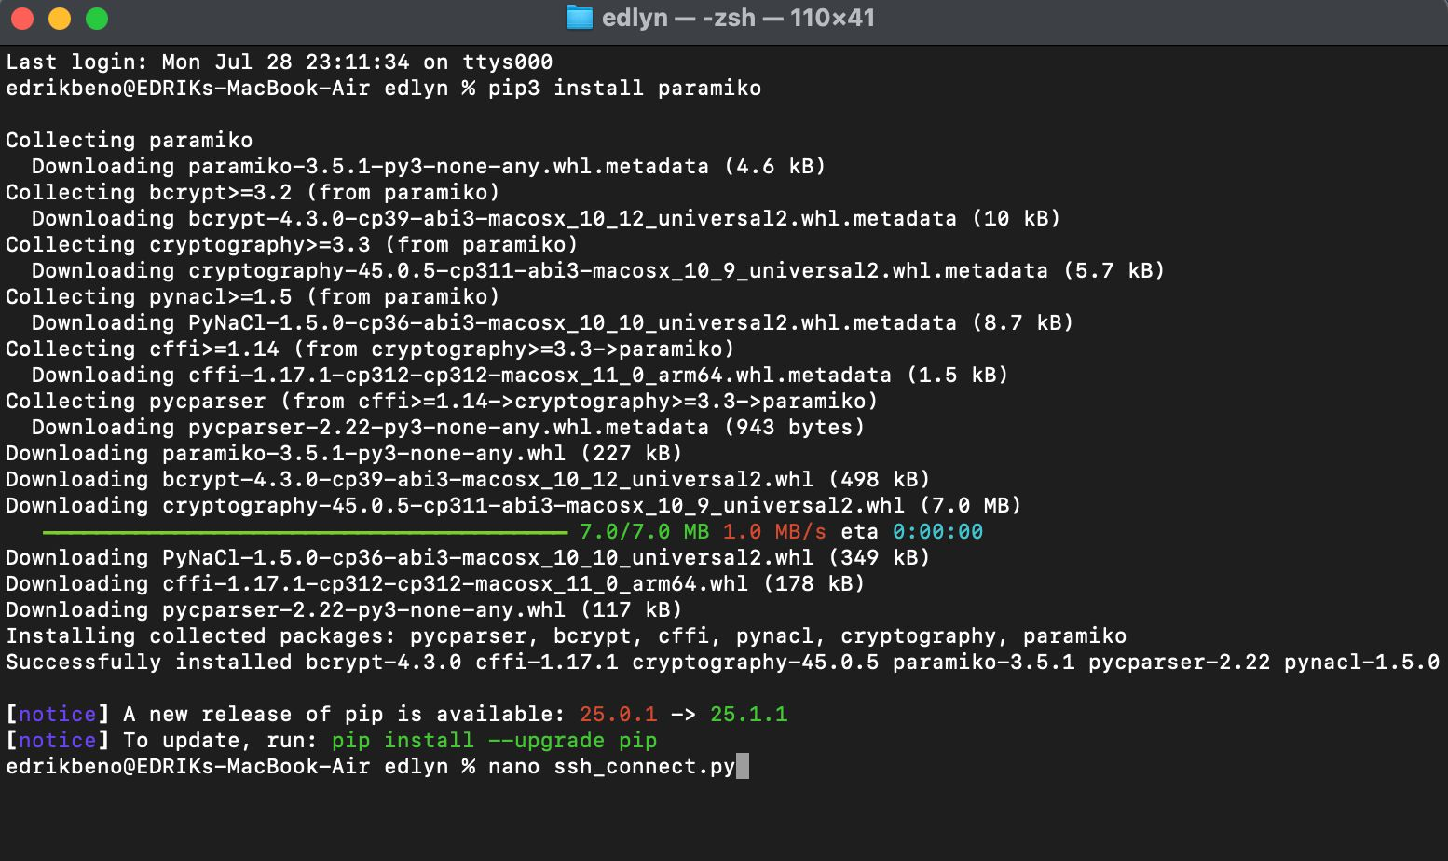

**Challenge 2**: Use Python subprocess to execute system commands and capture output.